/*1) List types of products ordered in 2009. The same part should not appear twice in the final list

(Hint: use built-in functions to extract year information from the date). */

**SELECT DISTINCT TYPE**

**FROM PRODUCTS JOIN ORDERS ON PROD=PROD_ID**

**WHERE YEAR(ORDER_DATE)=2009 AND MAN_ID=MAN**

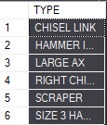

/*2) List types of products whose ordered quantity (i.e. quantity in a single order) is more than their

available quantity. The same product should not appear twice in the final list.*/

**SELECT DISTINCT TYPE**

**FROM PRODUCTS JOIN ORDERS ON PROD = PROD_ID**

**WHERE MAN=MAN_ID**

**GROUP BY TYPE, AV_QUANT**

**HAVING SUM(QUANT)>AV_QUANT**

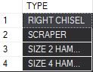

**/**\*3) List the customers the amount of a single order made by whom exceeds its credit limit. */

**SELECT COMP_NAME**

**FROM CUSTOMERS JOIN ORDERS ON CUST_ID=CUST_NUM**

**GROUP BY COMP_NAME, MAX_CREDIT**

**HAVING SUM(ORD_PRICE)>MAX_CREDIT**

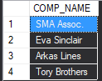

/*4-)List the order numbers and prices of orders taken by Northern offices. List should be ordered by

price in ascending order.*/

**SELECT ORDER_NUM,ORD_PRICE**

**FROM ORDERS JOIN EMPLOYEES ON REP_NUM=EMP_ID JOIN OFFICES ON OFFICE=OFFICE_ID**

**WHERE REGION='Northern'**

**ORDER BY ORD_PRICE ASC**

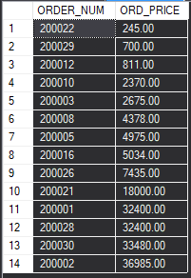

/*5-)Consider the employees whose sales are below their targets. List the names and ages of these

employees together with the names of their supervisors. List should be ordered with respect to

the ages of employees in descending order.*/

**SELECT E1.FL_NAME,E1.AGE,E2.FL_NAME AS SUPERVISOR_NAME**

**FROM EMPLOYEES AS E1 JOIN EMPLOYEES AS E2 ON E1.SUPERVISOR=E2.EMP_ID**

**WHERE E1.EMP_SALES < E1.EMP_TARGET**

**ORDER BY E1.AGE DESC**

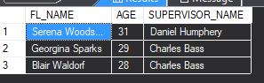

/*6-)List the all information of customers who did not make an order (Hint: use outer join and IS NULL

function. Keep in mind that your query should not be based on the values in the tables. It should

work even if the values are different than the ones given in handouts. )*/

**SELECT CUST_ID,COMP_NAME,CST_REP**

**FROM CUSTOMERS LEFT OUTER JOIN ORDERS ON CUST_ID = CUST_NUM**

**WHERE ORDER_NUM IS NULL**

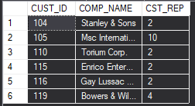

**--7-) List the total and average prices of orders made in 2008**

**SELECT SUM(ORD_PRICE) AS TOTAL,AVG(ORD_PRICE) AS AVARAGE**

**FROM ORDERS**

**WHERE YEAR(ORDER_DATE)=2008**



--8)List minimum, maximum and total prices of orders taken by Western offices

SELECT MIN(ORD_PRICE) AS MIN,MAX(ORD_PRICE) AS MAX,SUM(ORD_PRICE) AS SUM

FROM ORDERS JOIN EMPLOYEES ON REP_NUM=EMP_ID JOIN OFFICES ON OFFICE=OFFICE_ID

WHERE REGION='Western' /*Western????*/

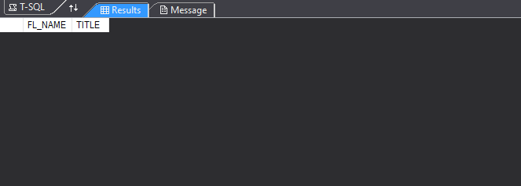

--9)List the names of companies whose sales representative is hired after year 2008.SELECT COMP_NAMEFROM CUSTOMERS JOIN EMPLOYEES ON CST_REP = EMP_IDWHERE YEAR(HIRE_DATE)> 2008

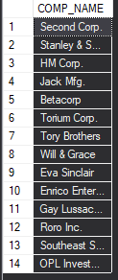

/*10-)list the names and titles of employees who are the managers of southern offices and older

than 40 years old.*/

SELECT FL_NAME,TITLE

FROM OFFICES JOIN EMPLOYEES ON MANAGER = EMP_ID

WHERE REGION ='Southern' AND AGE>40

**NO RESULT**



--11)What is the age average of employees in the company?

SELECT AVG(AGE) AS AVARAGE_AGE

FROM EMPLOYEES

